**User’s Guideline**

**The following User’s Guideline is considered as an integral part of the developed web application Comment Cloud**

The Comment Cloud platform is a platform for everyone who wants to add the comments' section to the website or blog without any complicated preparations and knowledge how to use the API and other tools. The Comment Cloud team guarantee a safety and privacy control for you and the visitors of your website/blog.  The step by step User’s Guideline presented below:

1. Please, go to the main page of the Comment Cloud: [https:// comment.cloud.itmo.xyz](https://metasploit.com/)

The programming language which was used for developing of Comment Cloud platform supports almost all operating systems and hardware architectures. There are no special hardware, software and programming languages requirements. You can implement the API call **at the backend** with any programming language (Python or other you prefer), **or at the frontend** with JavaScript or other programming language at your choice. The Comment Cloud platform provides a sample of API call and usage in JavaScript for testing.

1. At the home page you will see the registration panel where you need to enter your unique username, email and password.

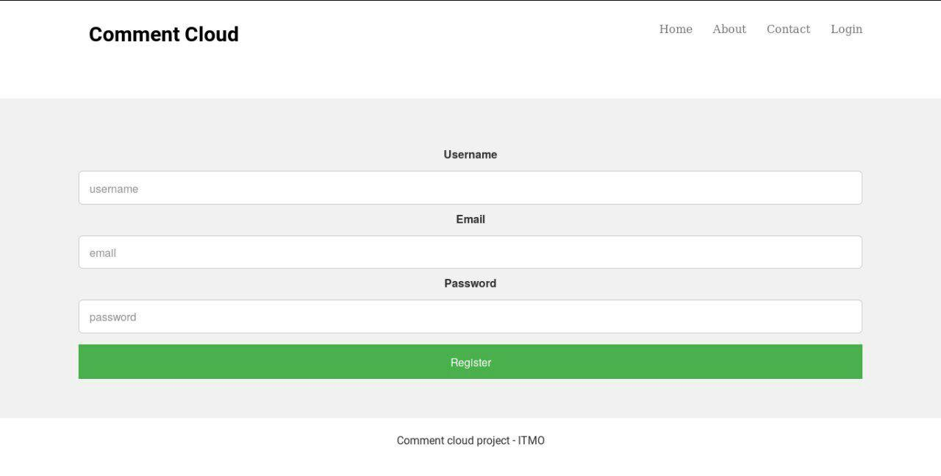

1. After registration you shall generate and safe the private key at the administrator’s panel, in order to use a Comment could functions and obtain API:

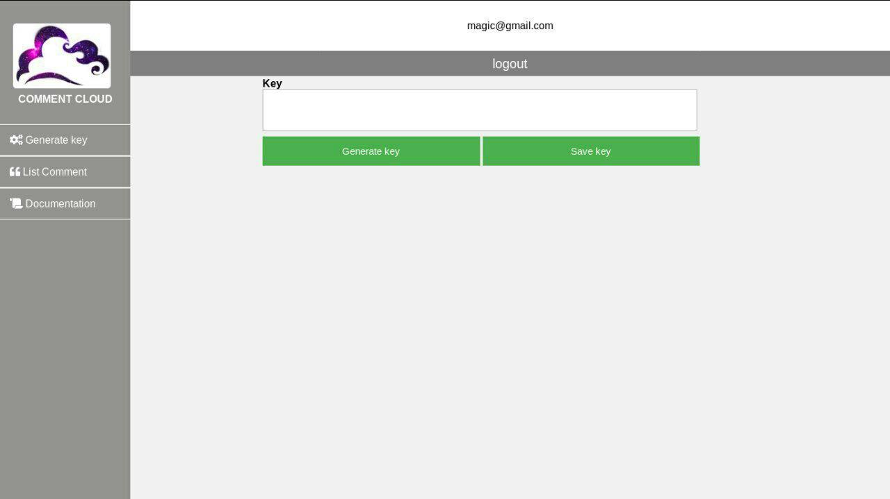

1. Now you have the rights of administrator and can do any manipulations within administrator’s panel, including implementation of the “comments” module (section) into your website, blog or application. You can always control this comments section and use an API provided to registered users of the Comment Cloud platform. **There are 2 endpoints which shall be defined** by you as well as its requirements and functionalities of each endpoint. The steps you shall do at this stage are:

**5.1) First endpoint:**

**/add.comment**

In order to add comments you have to send an json object to add one comment to the Comment Cloud platform: {"username": "Maxi", "comment_object_id": "grobb", "comment_text": "This is the this is"}

Then the token shall be generated and added as a parameter in the URL

Token = ##

Final url is: <https://comment.cloud.itmo.xyz/add.comment?token=>

**5.2.) Second endpoint:**

**/show**

Next, you shall add the token as a parameter and application will return you json object and all comments related/connected to you website.

Final url is: <https://comment.cloud.itmo.xyz/show?token=>

{"username": "Maxi", "comment_object_id": "grobb", "comment_text": "This is the this is"}

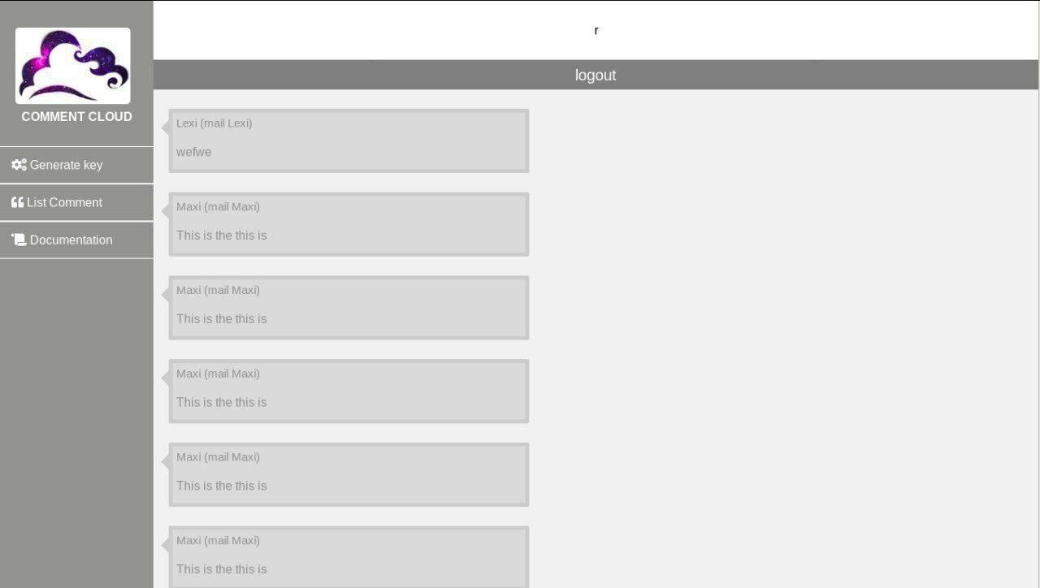

1. Do not forget to logout after you complete everything you needed.

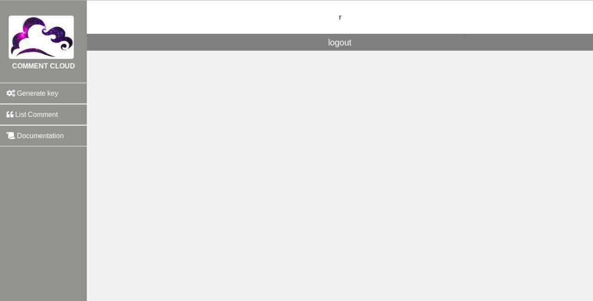

1. Next time you just need to insert your username and password in order to reach your panel:

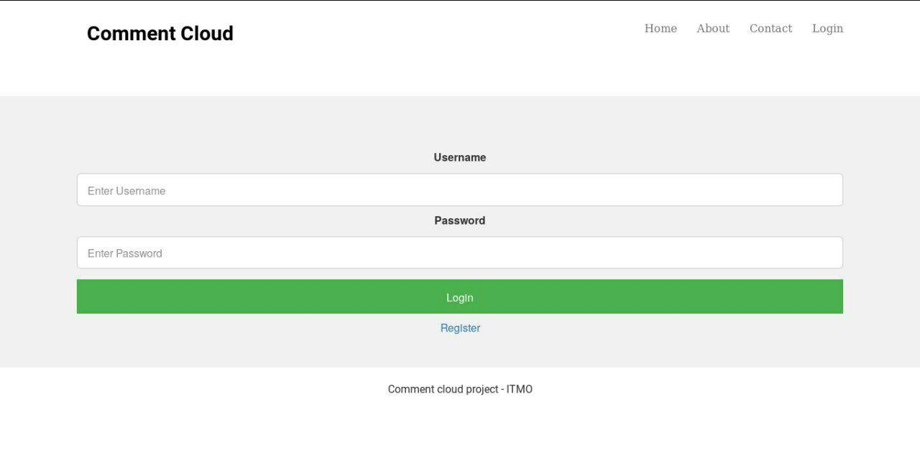

**Enjoy the work on Comment cloud platform!**